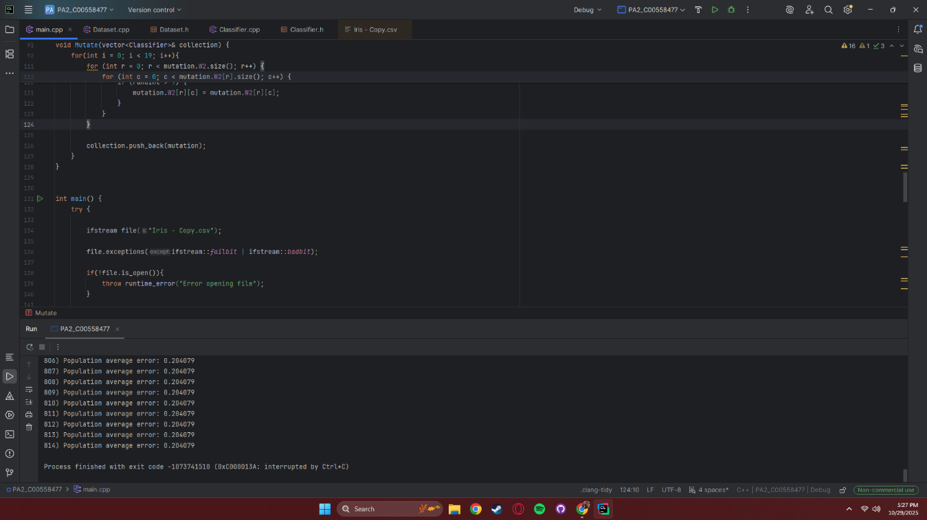
Problem 1). Here my average population error would consistently hit 0.204079 and turns out that was because most of my for loops were one short of the actual numbers. For example, with the mutation loop of 20 I did 0 < 19 thinking the zero would count making it loop 20 times. Because this was happening with most my loops the diversity wasn’t enough to actually improve any predictions. My population vector wouldn’t get filled with 50 items but would have like 46 items.

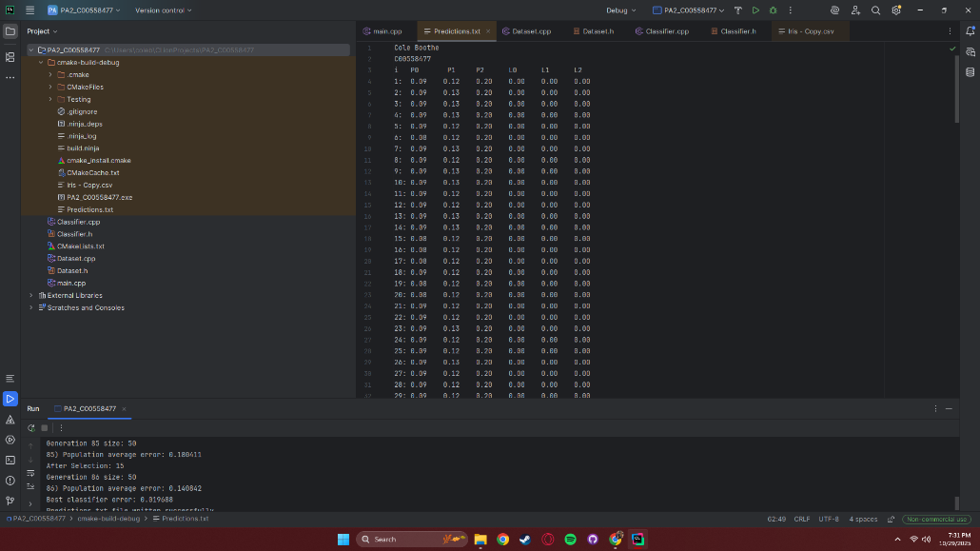
Problem 2). My predictions would print into the file but not the label of the species. Turns out in the Dataset Constructor my for loop to get the information for the line was looping three times not four times causing the program to skip the species from the line read.
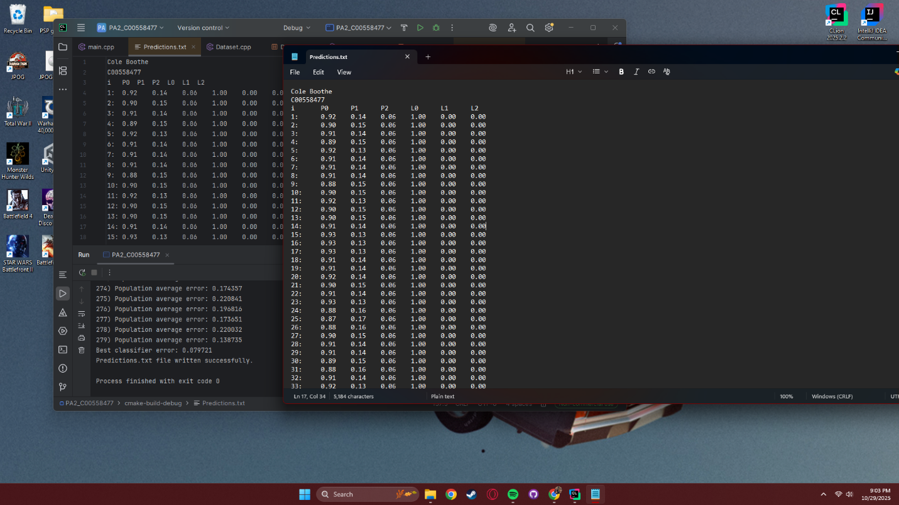
Problem 3). Reading the file from inside CLion the headers did not look like they were lined up but when you open the actual txt file the header is lined up. Also, when the program hit triple digits, the column would no longer be aligned so I added an extra \t behind the i in the header and tabbed after the “:” in the looping print statement.

This is the screenshot of my program working.